For Windows
- Install the Web Sphere Application Server and DB2 and then start both of them . Make sure that HTTPS service is running on port 8443 . ( For running on any other port , follow the instructions given at the end of this page *)

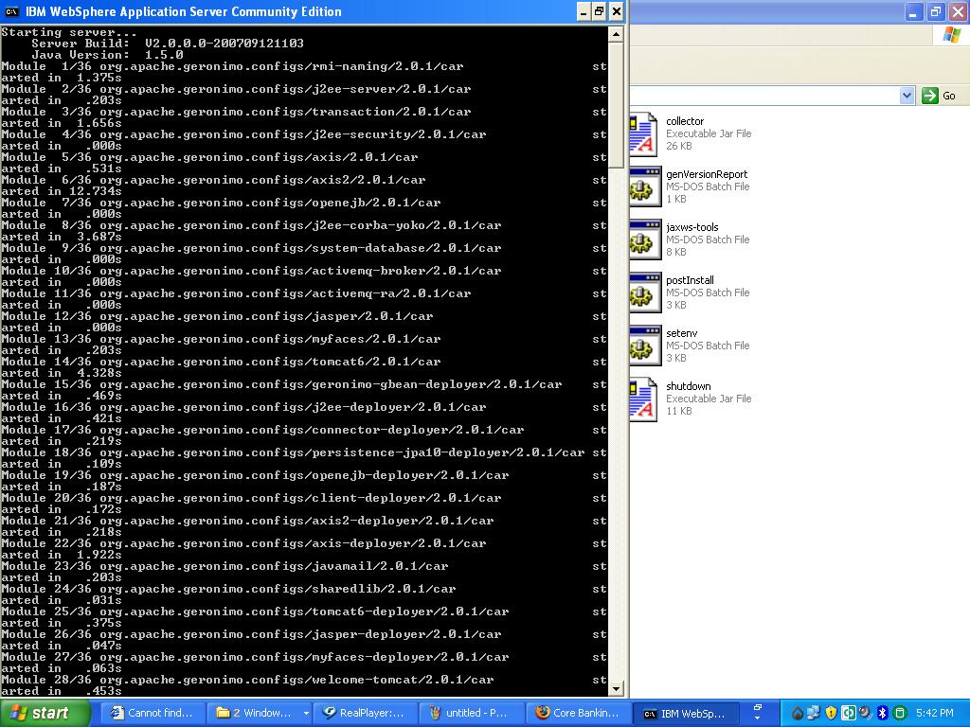

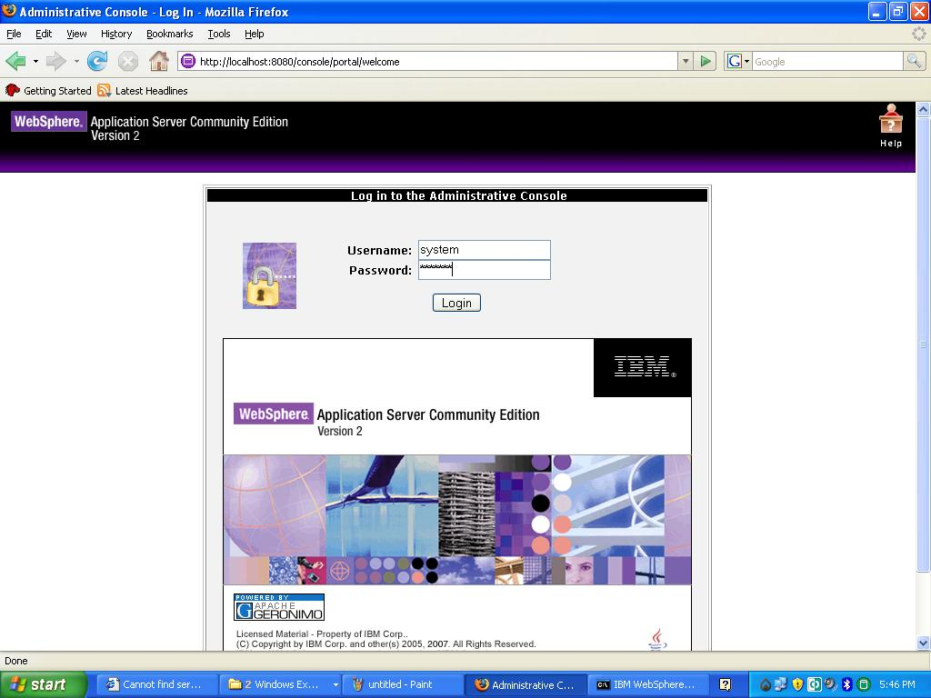

2. Switch to the DB2 user ( here we have assumed the DB2 user-id as: db2admin ).
3. Type the command : <db2 -vf core.sql -t > on the db2 command line.

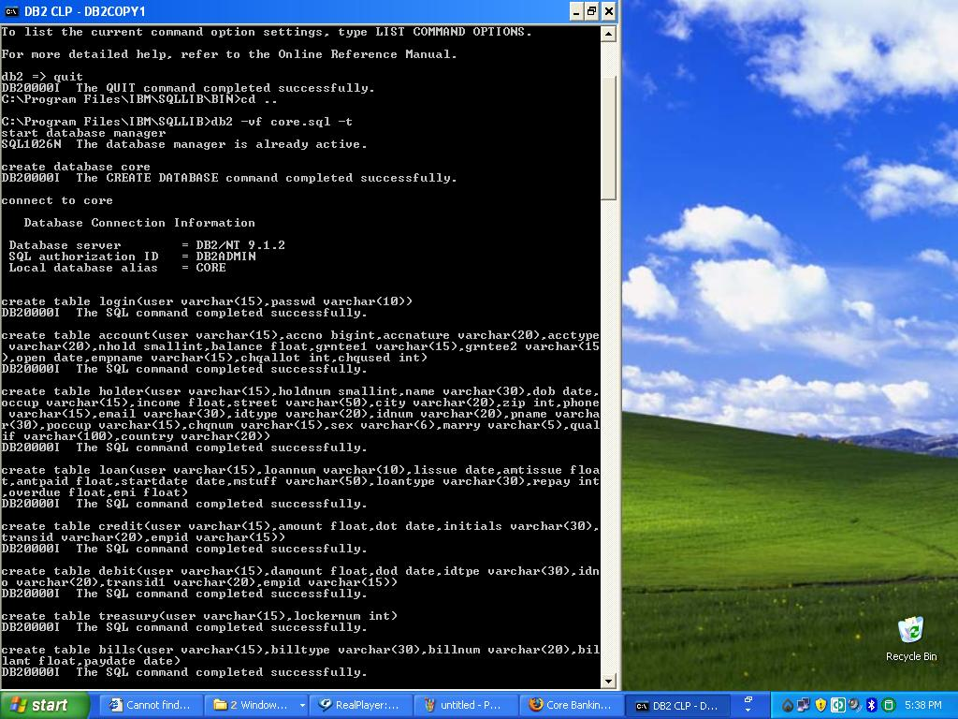

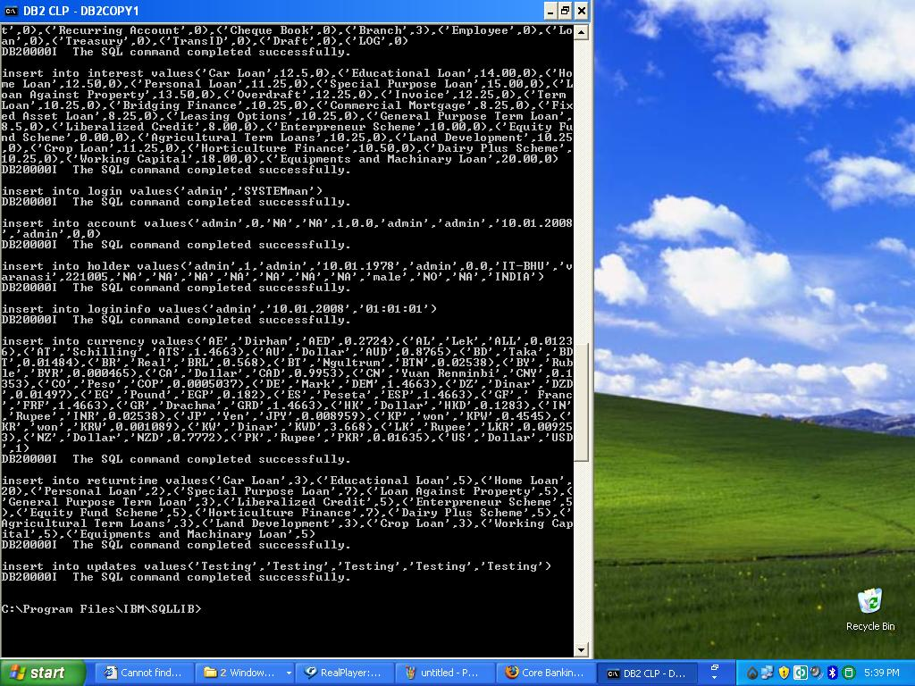

4. Switch to the original user.
5. Create database pool with the name "corepool " .

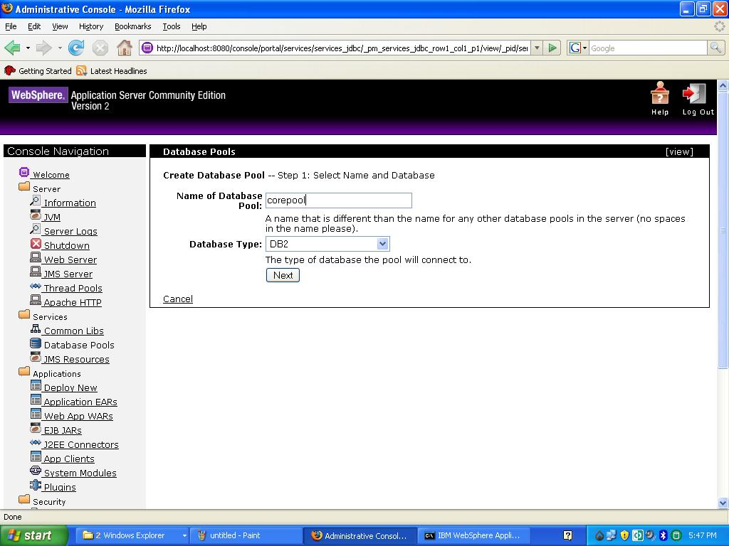

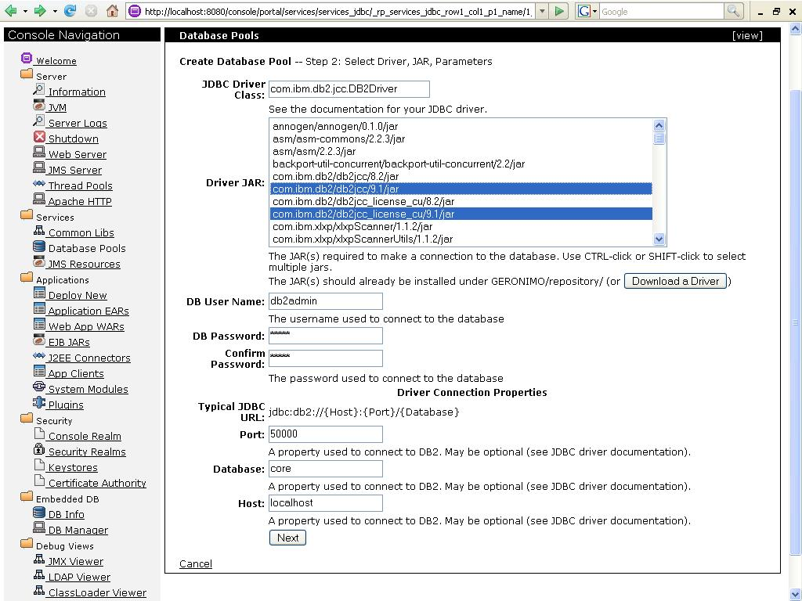

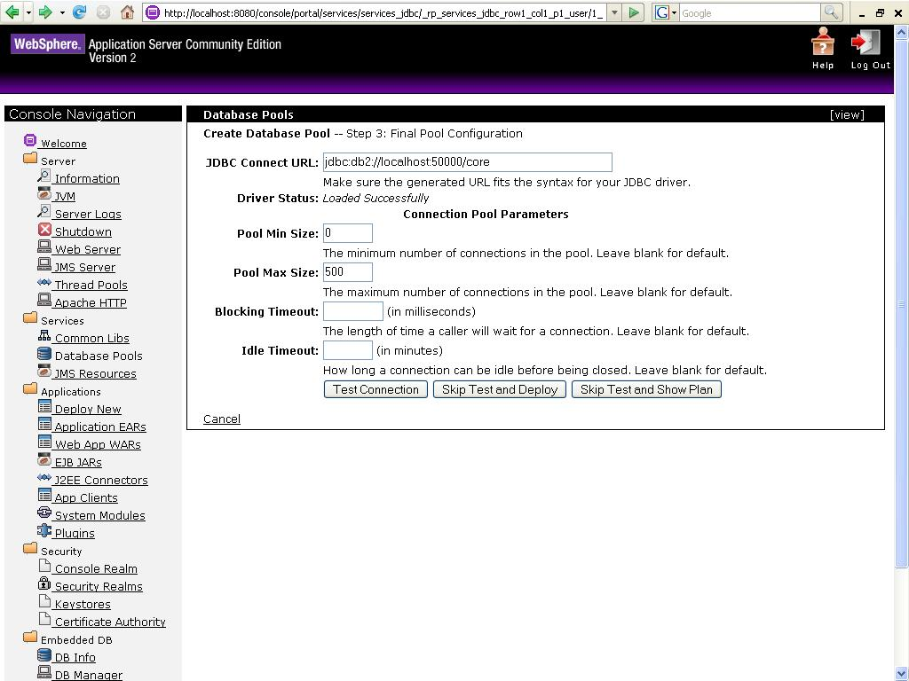

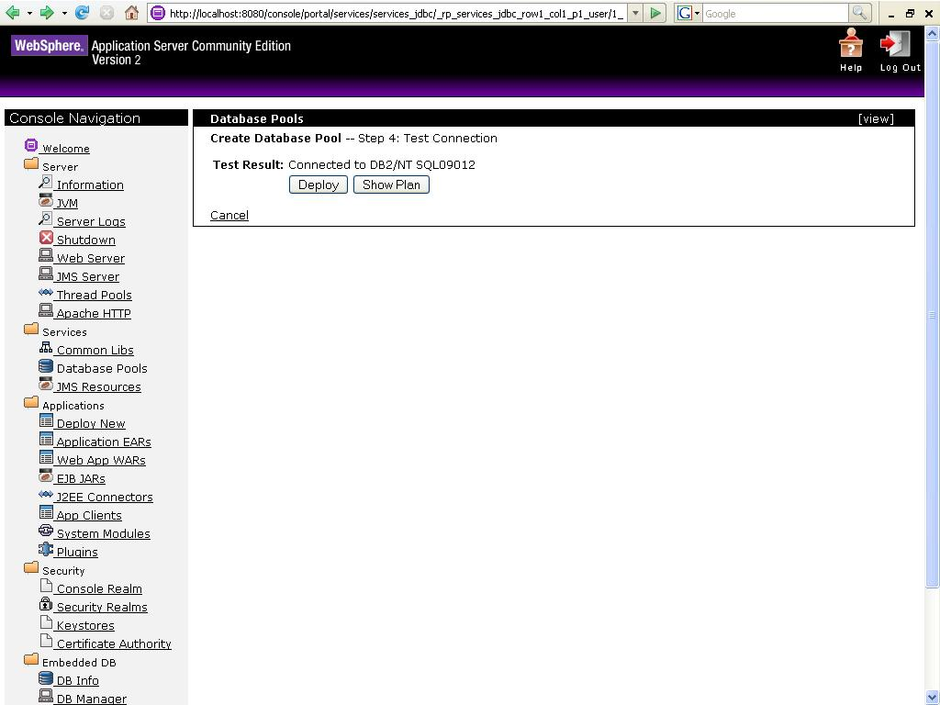

6. Deploy Core_Banking_win.war on the server.

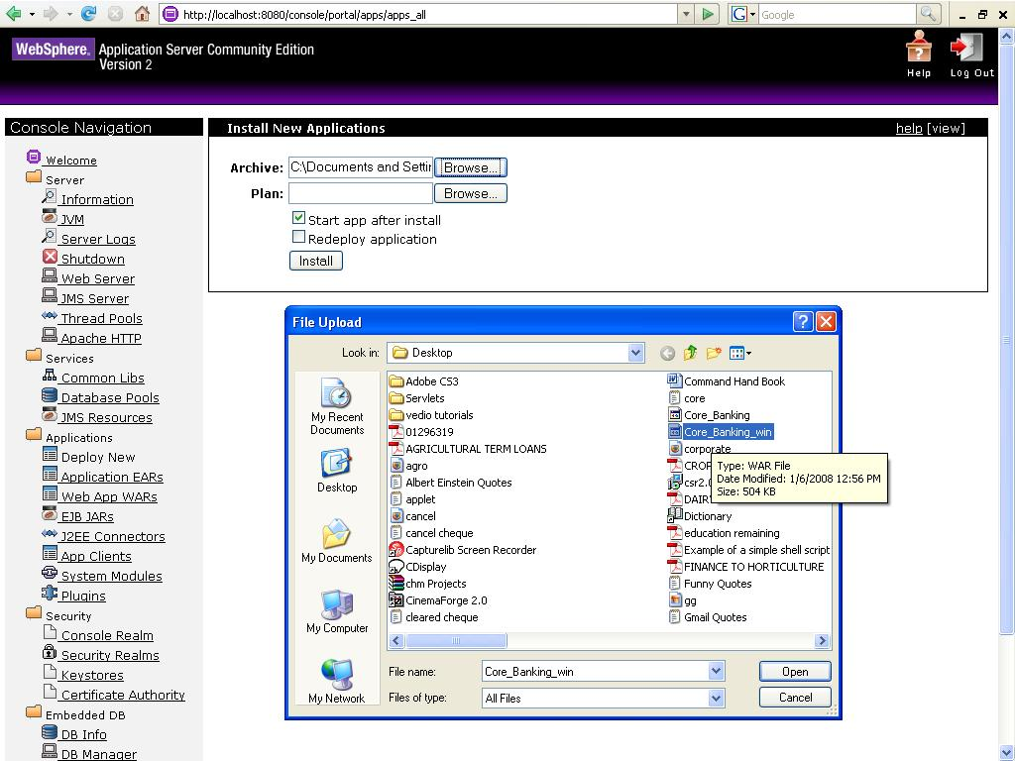

* NOTE :
In case HTTPS service is not running on port 8443 then traverse to the web application folder ( default location is c:/Program Files/IBM/WebSphere/AppServerCommunityEdition/repository/default/Core_Banking/1.0/Core_Banking-1.0.car/ ) and open the file index.jsp in a text editor . Below is a screenshot of the same.
Replace the highlighted port number with your desired port on which HTTPS service is running on your system .

